CIS 162

Ethan Carter

“I pledge that this work is entirely mine, and mine alone (except for any code provided by my instructor, or given references to stack overflow).” -Ethan Carter, June 20th 2019.

Zip Code Application (Java)

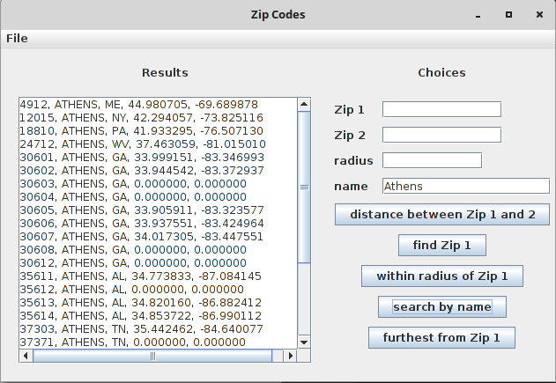

Project Source Code:

Please navigate to: [https://github.com/SamuraiYamma/CIS162](https://github.com/SamuraiYamma/162)

From there, click:

CIS162 → src → proj2

There are multiple files required to make this work:

Download all the .java files in proj2, and grab: zipData from CIS162.

Time Card: In the navigate to CIS → src → proj2 to view the timestamps.txt. Here you will find a detailed view of when I worked and what I did. Overall I spent nearly 16 hours on this project from June 11th to June 20th.

References: [https://stackoverflow.com/questions/27928/calculate-distance-between-two-latitude-longitude-points-haversine-formula#27943](https://stackoverflow.com/questions/27928/calculate-distance-between-two-latitude-longitude-points-haversine-formula" \l "27943)